SCHOOL NAME **Semester 2 Examination 2012**

**MATHEMATICS Question/Answer Booklet**

**3C/3D**

Section Two:

Calculator-assumed:

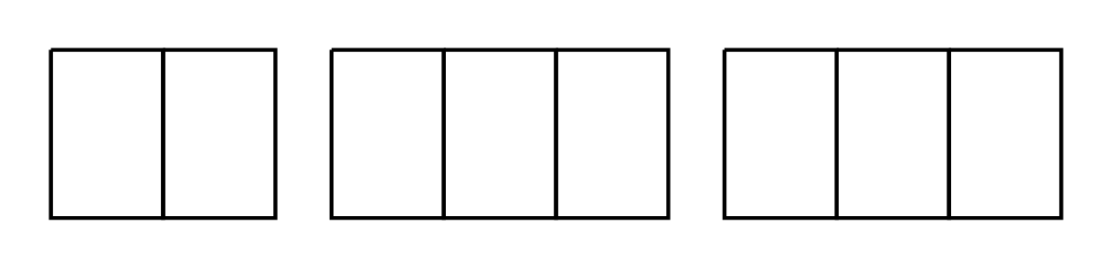

Student Number: In figures

In words ____________SOLUTIONS________

____________________________________

**Time allowed for this section**

Reading time before commencing work: ten minutes

Working time for this section: one hundred minutes

**Materials required/recommended for this section**

***To be provided by the supervisor***

This Question/Answer Booklet

Formula Sheet (retained from Section One)

***To be provided by the candidate***

Standard items: pens, pencils, pencil sharpener, eraser, correction fluid/tape, ruler, highlighters

Special items: drawing instruments, templates, notes on two unfolded sheets of A4 paper, and

up to three calculators satisfying the conditions set by the Curriculum Council

for this examination.

**Important note to candidates**

No other items may be used in this section of the examination. It is **your** responsibility to ensure that you do not have any unauthorised notes or other items of a non-personal nature in the examination room. If you have any unauthorised material with you, hand it to the supervisor **before** reading any further.

**Structure of this paper**

|  |  |  |  |  |  |
| --- | --- | --- | --- | --- | --- |
| Section | Number of questions available | Number of questions to be attempted | Working time (minutes) | Marks available | Percentage of exam |
| Section One:  Calculator-free | 7 | 7 | 50 | 50 |  |
| Section Two:  Calculator-assumed | 14 | 14 | 100 | 100 |  |
|  |  |  |  |  | 100 |

|  |  |  |
| --- | --- | --- |
| **Question number** | **Marks allocated** | **Marks awarded** |
| 8 | 5 |  |
| 9 | 5 |  |
| 10 | 7 |  |
| 11 | 11 |  |
| 12 | 9 |  |
| 13 | 11 |  |
| 14 | 6 |  |
| 15 | 9 |  |
| 16 | 10 |  |
| 17 | 7 |  |
| 18 | 11 |  |
| 19 | 9 |  |

**Instructions to candidates**

1. Write your answers in the spaces provided in this Question/Answer Booklet. Spare pages are included at the end of this booklet. They can be used for planning your responses and/or as additional space if required to continue an answer.

* Planning: if you use the spare pages for planning, indicate this clearly at the top of the page.
* Continuing an answer: If you need to use the space to continue an answer, indicate in the original answer space where the answer is continued i.e give the page number. Fill in the number of the question(s) that you are continuing to answer at the top of the page.

2. **Show all your working clearly.** Your working should be in sufficient detail to allow your answer to be checked readily and for marks to be awarded for reasoning. Incorrect answers given without supporting reasoning cannot be allocated any marks. For any question or part question worth more than two marks, valid working or justification is required to receive full marks. If you repeat an answer to any question, ensure that you cancel the answer you do not wish to have marked.

3. It is recommended that you **do not use pencil**, except in diagrams.

**Question 8 (5 marks)**

Three events are such that

(a) Show that events B and C are mutually exclusive. (1 mark)

i.e so are mutually exclusive ✓

(b) Determine which of the three events are independent. Justify your answer. (4 marks)

so *B* and *C* are not independent. ✓

Since , *A* and *B* are not independent ✓

so ✓

are independent. ✓

**Question 9 (5 marks)**

A student catches the bus to school each day. The amount of time the student has to wait for their bus varies between 1 minute and 15 minutes, and is uniformly distributed.

For each question below, clearly state the probability distribution you are using, as well as its parameters.

(a) Determine the probability that on a particular day the student waits more than 5 minutes, given that they wait less than 10 minutes. (2 marks)

Let *X* represent the waiting time on a particular day.

ie

✓

✓

(b) The waiting time for the student on any particular day is independent of the waiting time on other days. Determine the probability that in any period of 10 days, the student has to wait less than 10 minutes on exactly 8 of those days. (3 marks)

Let *Y* represent the number of days waiting less than 10 minutes

✓

✓✓

**Question 10 (7 marks)**

The mining town of Diggitup has been experiencing constant exponential growth over the last decade. The population of the town 10 years ago was 10 000, and there are now (at the beginning of 2012) an extra 1600 people living in the town.

(a) Assuming that the growth rate of the population *P* remains the same in the future, use this information to write an equation to predict the population of Diggitup *t* yearsfrom the beginning of 2012. (2 marks)

* ✓

(b) Hence predict the population of Diggitup at the beginning of 2020.

(1 mark)

✓

(c) The nearby town of Fillitin has also been growing, but its population growth has been such that the equation to predict its population *F* in *t* years time

(from the beginning of 2012) is

1. What is the current population (as of the beginning of 2012) of Fillitin? (1 mark)

✓

1. During which years will the population of Fillitin be greater than the population of Diggitup, according to these equations?

(3 marks)

Solving

gives *t* values of 9.74 and 42.71 ✓

when ✓

i.e from 2022 to 2054 ✓

**Question 11 (11 marks)**

To raise money at a school féte some parents decide to run a pie and pastie stall.

Each pie requires 100g of dough, 100g of vegetables and 200g of meat. Each pastie requires 100g of dough, 200g of vegetables and 100g of meat. The parents have ordered 23kg of dough, 38kg of vegetables and 35kg of meat. 30 people have preordered pies, and 20 have preordered pasties.

If the parents make *x* pies, and *y* pasties, four of the five restrictions that apply to this situation are:

.

(a) Write the inequality for the fifth restriction. (1 mark)

or ✓

(b) Graph this inequality on the graph below, and shade the feasible region.

(2 marks)

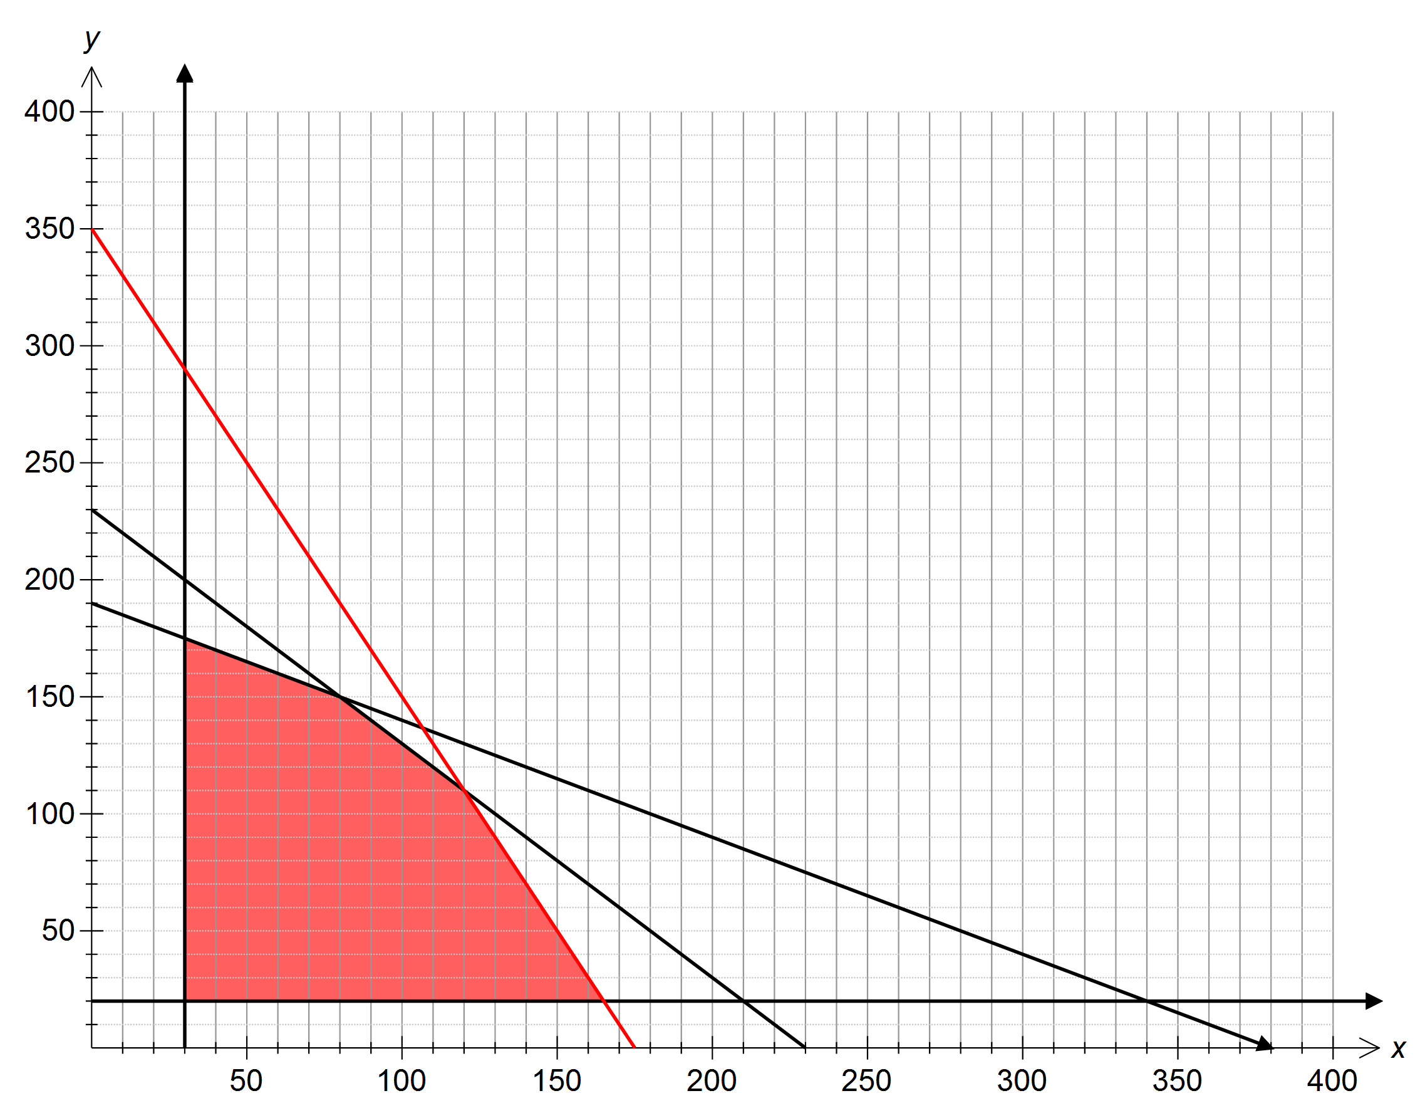

✓- correct line ✓-correct region

**Question 11 (continued)**

(c) If each pie sells for $2.30, and each pastie sells for $2.10, how many of each should be made to maximise revenue? State the maximum revenue. (4 marks)

|  |  |
| --- | --- |
| Corners of region | 2.3*x* + 2.1*y* |
| (30,20) | $111 |
| (30,175) | $436.50 |
| (80,150) | $499 |
| (120,110) | $507 |
| (165,20) | $421.50 |

✓✓ correct corners

120 pies and 110 pasties ✓

Maximum revenue of $507

(d) Which ingredient is left over, and by how much if the parents make the number of pies and pasties for the optimum situation in part (c)? (2 marks)

Dough: Amount used kg so 0 left over

Meat: Amount used kg so 0 left over

Vegetables: Amount used kg

4kg of vegetables left over

✓ ✓

(e) Assuming that the price of a pastie remains at $2.10, by how much could they increase the price of a pie before the optimum situation in part (c) changes? (2 marks)

No longer unique solution when revenue gradient matches that of

or gradient of

Revenue equation

To match , but this is reduction in price.

To match ,

Therefore the price of the pie could increase to $4.20 before the solution changes.

Thus the price of the pie could increase by up to $1.90 ✓✓

**Question 12 (9 marks)**

A motorist travels through three sets of traffic lights on their way to work each day. They have noticed that there is a 40% probability of getting a green light at the first set of lights.

If they get a green light at the first set of lights, the probability of getting a green light at the second set of lights is 80%, however if they did not get a green light at the first set of lights the probability of getting a green light at the second set of lights is only 25%.

At the third set of lights, the motorist has a 70% probability of getting a green light if they got a green light at the second set of lights, but if they did not get a green light at the second set of lights, there is a 50% probability of getting a green light.

(a) Complete the tree diagram below to show the probability of each outcome at the three sets of lights. (3 marks)

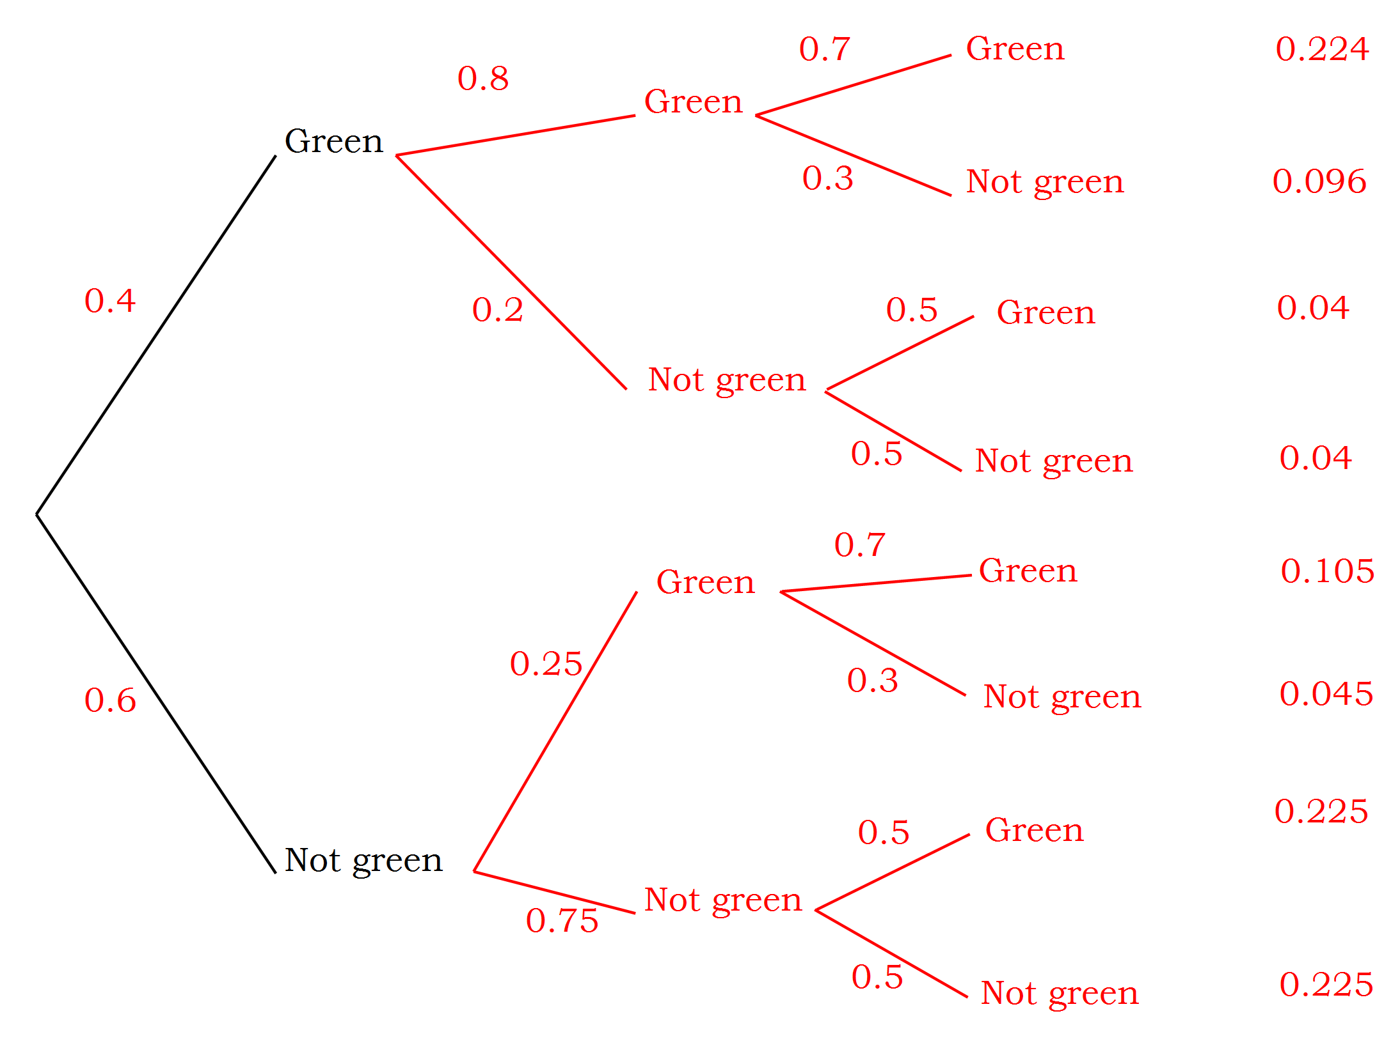

✓✓✓- correct probability on each branch (-1 error)

(b) Determine the probability that the motorist

(i) got no green lights. (1 mark)

✓

(ii) got green lights at exactly two sets of lights. (2 marks)

or or

✓✓

(iii) got a green light at the first set of lights, given that they got a green light at the last set of lights. (3 marks)

✓

✓✓

**Question 13 (11 marks)**

The graph below shows the **derivative** of a function

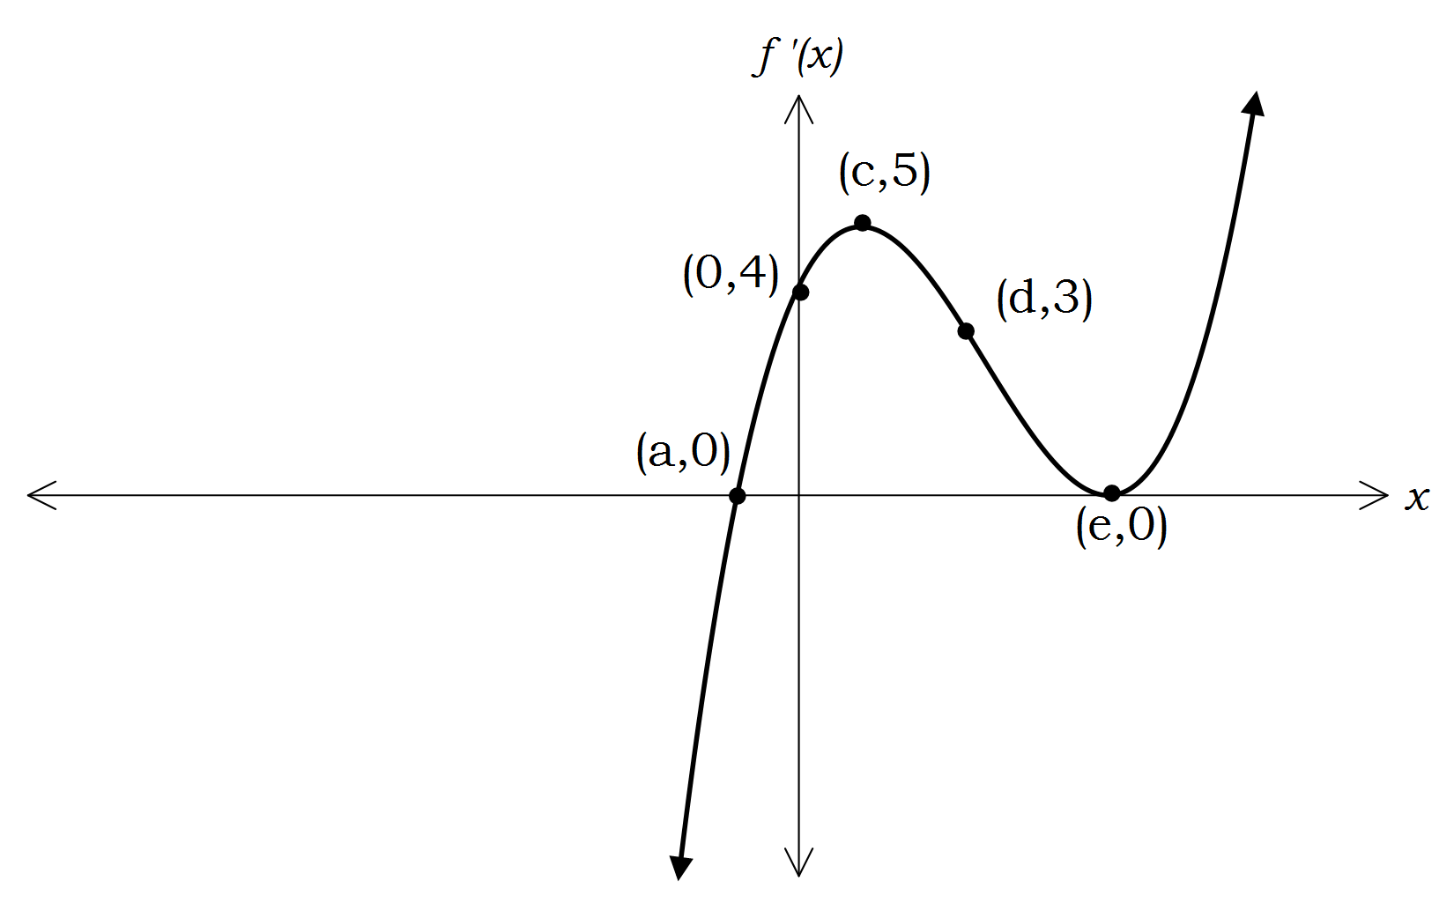

(a) Use the graph of to determine the *x-*values of all stationary points of the original function (and their nature) and the *x-*values of the points of inflection. (5 marks)

Stationary points occur when and

Since goes from negative to positive as *x* passes *a*, there is a minimum value when ✓ ✓

Since is positive either side of , there is a horizontal point of inflection when ✓ ✓

has a turning point when , so this is a point of inflection. ✓

(b) Given that the original function passes through the point , write an equation (in terms of *d)* for the line that is tangential to the function at

. (3 marks)

so gradient of tangent is 3✓

So equation of tangent is .

Substituting gives ✓

Tangent equation is ✓

(c) Given that the equation of the derivative is , write an expression for *k* in terms of *a* and *e*, and hence write an expression for the second derivative in terms of *a* and *e* only. (3 marks)

Since , i.e ✓

✓✓

**Question 14 (6 marks)**

At the Kumm-Fee sofa factory, it was found that the instantaneous rate of production *t* hours into a shift followed the equation

(a) What is the appropriate domain for the function in this context?

(1 mark)

Since just after , a suitable domain is ✓

(b) (i) Write an expression using integration to determine the total

production in the *n*th hour of the shift. (1 mark)

Total production in nth hour ✓

1. Hence or otherwise determine the total production in the sixth hour of the shift. (1 mark)

Production in 6th hour = = 74 items ✓

(c) (i) Write an expression for the average production rate over the first *n*

hours of the shift. (1 mark)

✓

1. Hence determine at what time during the shift the average production rate during the shift is the same as the instantaneous production at that time. (2 marks)

Solving gives

Since the average production is undefined for ,

the only solution is i.e 7.5 hours into the shift ✓✓

**Question 15 (9 marks)**

The camping supplies provider For All In Tents has designed a two person tent in

the shape of an equilateral triangle based prism, as shown in the diagram below.

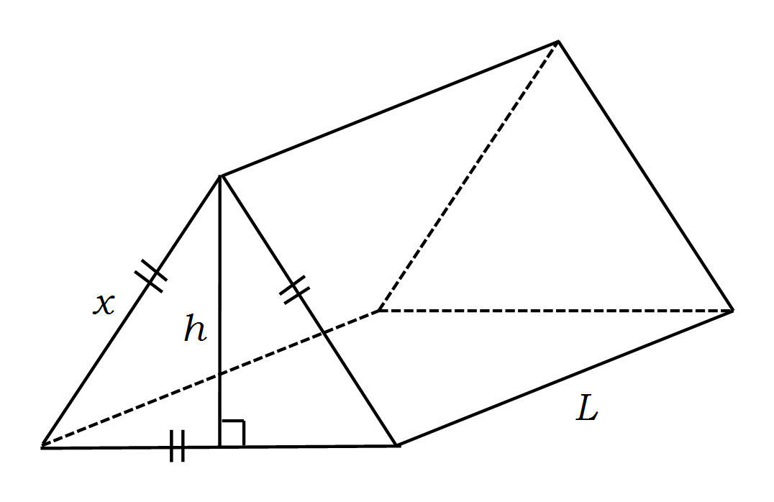

(a) If the length of each side of the equilateral triangle is *x*, use the fact that the perpendicular height of an equilateral triangle bisects the base to show that the perpendicular height, *h*, of the triangle is given by the formula

(2 marks)

✓

✓

(b) Hence determine an expression for the volume of the tent in terms of *x*

and *L* only*.* (1 mark)

✓

i.e

(c) Given that the tent must have a volume of 3m3, write *L* in terms of *x* only.

(1 mark)

✓

(d) The material to make the walls of the tent costs $8/m2, and the material to

make the floor costs $12/m2. Use this information to write an expression in terms of *x* only for the total cost of fabric for the tent. (3 marks)

✓

or

Floor sides

Cost

✓ ✓

(e) Determine the value of *x* that will minimise the cost of the material for the tent. State this minimum cost. (2 marks)

Minimum cost of $120.73 when *x =* 2.41m

✓ ✓

**Question 16 (10 marks)**

A champagne glass is shaped by rotating the curve around the *x* axis from 0 to *h*, where *h* is the height of the glass.

(a) Write an expression in terms of *h* for the volume of the glass.

(2 marks)

✓✓

(b) Determine the height of one of these champagne glasses if it is to have a volume of 120cm3. (2 marks)

✓✓

(c) Use the incremental formula to determine the percentage change in height associated in a 1% increase in the volume of the glass. (3 marks)

✓

✓

This represents a 0.5% increase in height ✓

(d) If liquid is being poured into the glass at a rate of 10cm3/sec, use related rates to determine the rate at which the height of liquid is increasing when there is 50cm3 of liquid in the glass. (3 marks)

✓ When so ✓

✓

**Question 17 (7 marks)**

A four person committee is to be formed from a group of 6 women and 8 men.

(a) What is the probability that such a committee contains Tony (a man) or Julia (a woman) but not both? (2 marks)

Total combinations

Exactly one of Tony and Julia

(b) (i) Determine the probability that the committee contains more women

than men. (2 marks)

Committees with 3 women, 1 man

Committees with 4 women

(ii) How many ways are there of selecting a committee with more women than men and arranging them for a photograph so that the women are together? (3 marks)

Arranging 3 women, 1 man with women together

Arranging 4 women with women together

So total arrangements

**Question 18 (11 marks)**

A brand of dog food, Kennel Sanders, sells the food in tins that are labelled as containing 580g of the dog food. The filling machine is calibrated such that the amount of food that goes into each tin is normally distributed, with a mean of 585g and a standard deviation of 6g.

For each question below, clearly state the probability distribution you are using, as well as its parameters.

(a) Determine the probability that a randomly selected tin contains less than the labelled weight. (2 marks)

Let *X* represent the weight in a tin

✓✓

(b) Given that a randomly selected tin does not contain less than the stated weight, what is the probability that it contains less than 595g of dog food?

(3 marks)

✓

✓

✓

(c) Given that the weight of dog food in each tin is independent of the weight of food in any other tin, determine the probability that a sample of ten tins will contain no more than 3 tins with less than the labelled weight of dog food.

(2 marks)

Let *Y* be the number of underweight tins in the sample.

✓✓

(d) The manufacturers of the dog food wish to reduce the probability of tins containing less than the labelled weight to 0.005, while having no more than 1% of tins containing more than 590g of food. Determine the new mean and standard deviation, to 3 significant figures, needed for the filling machine to achieve these aims. (4 marks)

and

On the standard normal distribution

produces a *k* value of -2.5758

produces a c value of 2.3263 ✓

Since and two equations can be formed.

and ✓

Solving these equations simultaneously gives to 3 s.f

✓ ✓**Question 19 (9 marks)**

A survey of 230 adults determined that their average “comfortable” walking pace was normally distributed with a mean of 4.97 km/h and a standard deviation of 0.67 km/h.

For each question below, clearly state the probability distribution you are using, as well as its parameters.

(a) Determine a 95% confidence interval for the population mean “comfortable” walking speed for adults, assuming the population standard deviation is the same as the sample standard deviation. (3 marks)

95% confident that population mean is within 1.96 s.d of sample mean,

where s.d = ✓

Solving

Gives a confidence interval of ✓✓

(b) If a second survey is to be conducted, what is the minimum number of participants required for this second survey to be 99% confident that the mean of this second survey is within 0.1 km/h of the population mean, assuming that the population mean is equal to the mean of the original sample? (3 marks)

✓

✓✓

(c) To determine whether talking on mobile phones made a difference to walking speed, a sample of 33 adults was taken, and their “comfortable” walking speed while talking on the mobile phone was found to have a mean of 4.5 km/h. Determine whether this mean is significantly different from the population mean at the 1% level, assuming that the population mean is equal to the original sample mean. (3 marks)

The sample means for samples of size 33 will be normally distributed with a mean of 4.97 km/h and standard deviation of . ✓

95% of the sample means will lie between and

km/h i.e between 4.67 km/h and 5.27km/h ✓

Since 4.5km/h is outside this range, it is significantly different at the 1% level. ✓

**Additional working space**

Question number:______

ACKNOWLEDGEMENTS

Section Two:

**Question 19** Data source: *Comfortable and maximum walking speed of adults aged 20-79 years* by Richard W Bohannon

Retrieved May 2012 from http://ageing.oxfordjournals.org/content/26/1/15.full.pdf